

**The Evaluation of the Social Services and Well-being (Wales) Act 2014**



**Study information**

[](https://www.bing.com/images/search?view=detailV2&ccid=nqGq2LC4&id=717252092803D9251F9CA2E5DA52558DBAA459EF&thid=OIP.nqGq2LC4yfgnHKoOywwaOAHaHi&mediaurl=https://www.clker.com/cliparts/n/J/Z/w/Y/a/law-hi.png&exph=598&expw=588&q=legislation+clip+art&simid=607987288670603869&selectedIndex=0)

**What will the project do?**

We are looking at a government policy called the Social Services and Well-being (Wales) Act



We want to talk to you about the support you receive. For example, if you are happy with the help you have or if you think it could be better.

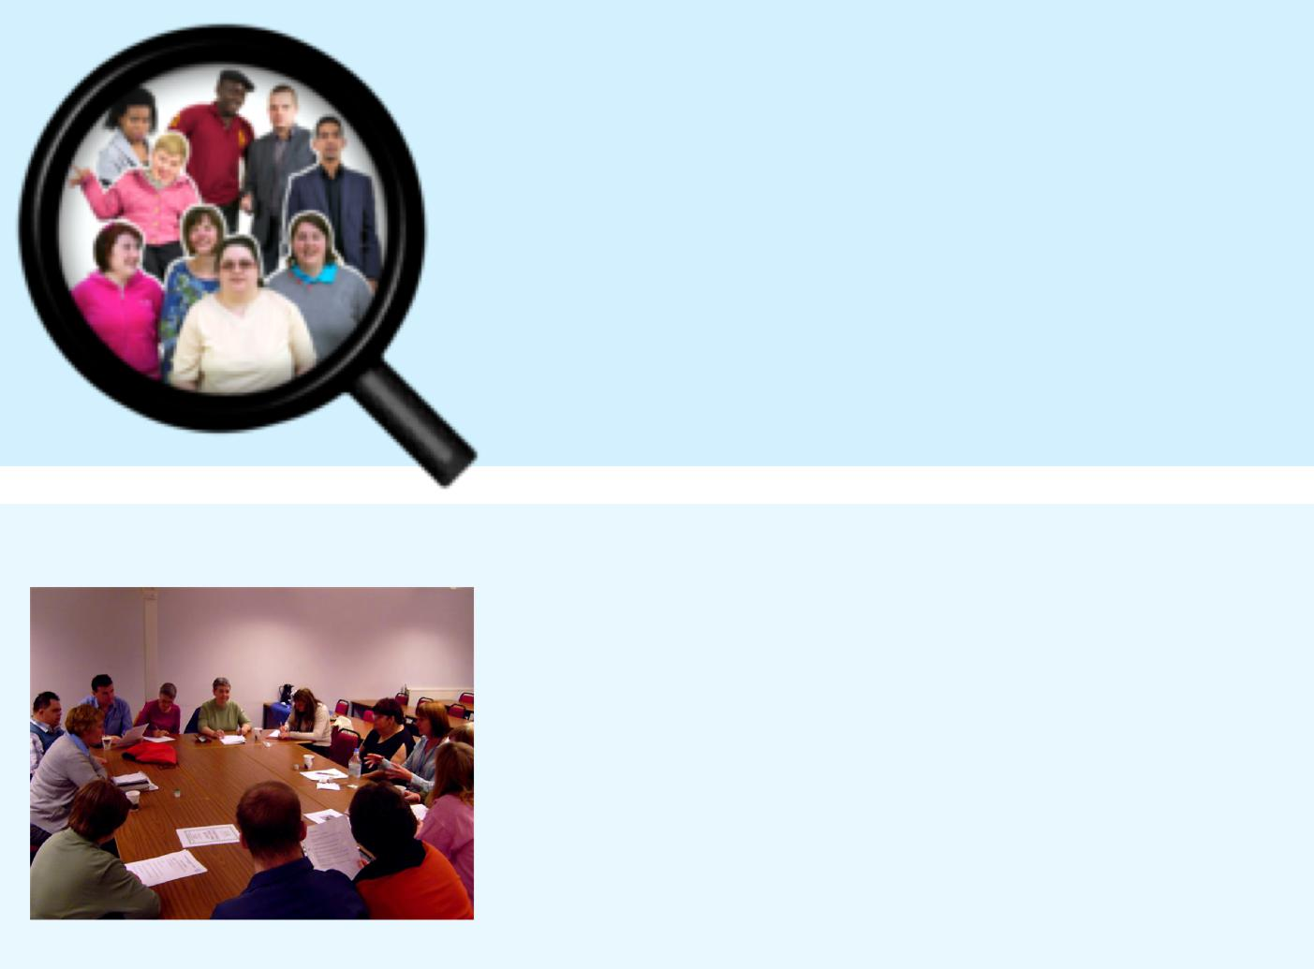

**Who will take part in the research project?**

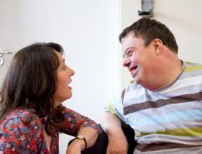

People living in Wales who receive care and support will be asked if they would like to take part



**How will we do this?**



You can talk on your own with a researcher

**Or** Within a group

**And**

You can have someone you know with you or not

**You decide**

**Will what I say be kept private?**

What you say will be **private**

**but** if I think you, or someone else, is not safe I will have to tell other people

[](https://www.bing.com/images/search?view=detailV2&ccid=5MtDuhwj&id=E3B2ECCB1ECA7E47E900417CC658640FF4FEE33F&thid=OIP.5MtDuhwjivvmt81SVt0cSwHaE8&mediaurl=https://www.dpnetwork.org.uk/wp-content/uploads/2017/06/Privacy.-Security-of-personal-data-513639320_3000x2000.jpeg&exph=2000&expw=3000&q=Privacy&simid=608000289516160846&selectedIndex=0)

[](https://www.google.co.uk/imgres?imgurl=https://clipground.com/images/red-cross-box-clipart-12.jpg&imgrefurl=https://clipground.com/red-cross-box-clipart.html&docid=F0OtaOhLmobJ5M&tbnid=WStd7Mfn8LEykM:&vet=10ahUKEwj-zvnzhZ7jAhUFiVwKHThEAU8QMwiyAShZMFk..i&w=1300&h=778&bih=750&biw=1368&q=tick%20and%20cross%20clipart&ved=0ahUKEwj-zvnzhZ7jAhUFiVwKHThEAU8QMwiyAShZMFk&iact=mrc&uact=8)

You do not have to take part in the research. **It is your choice**

You can change your mind about taking part or stop at anytime

[](https://www.google.co.uk/imgres?imgurl=http://clipart-library.com/image_gallery/196060.gif&imgrefurl=http://clipart-library.com/questions-cliparts.html&docid=gWfS9NMjs3syyM&tbnid=TUUBx053_mb9kM:&vet=10ahUKEwiTm8fFjZ7jAhWCoXEKHXvYAAsQMwilASgaMBo..i&w=178&h=194&bih=750&biw=1368&q=questions%20clipart&ved=0ahUKEwiTm8fFjZ7jAhWCoXEKHXvYAAsQMwilASgaMBo&iact=mrc&uact=8)

If you have any **questions**, you can ask the researcher

**Or**

Professor Mark Llewellyn who is in charge of the study

Email: mark.llewellyn@southwales.ac.uk

Telephone: 01443 483069

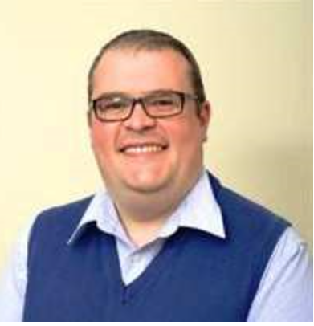

[](https://www.bing.com/images/search?view=detailV2&ccid=hN2Q8GFk&id=BE94415270C92B8968C7948C13E754AC62D18B5E&thid=OIP.hN2Q8GFk1UxPmmVeeV6e-AHaDI&mediaurl=http://www.crewdetroit.org/wp-content/uploads/2015/07/thank-you-photo.jpg&exph=845&expw=2000&q=thank+you+&simid=607989388898599352&selectedIndex=24)