Understanding the Act
The Social Services and Well-being Act has five principles to make life better for people who get care and support and their carers.
- Voice and Control

The Act aims for people to make choices and be listened to.

This means people can get the results that matter most to them.

- Prevention and early intervention

The Act aims for people to get help they need.

This helps problems stop before they get worse.

- Co-production

The Act aims for people to take part in the design of their care and support.

This means working together as equals so care and support is the best it can be.

- Multi-agency

The Act aims for care and support organizations to work together well.

This means there will be the right support in communities to meet people’s needs.

- Well-being

The Act aims for people to have well-being in every part of their lives.
Well-being is more than being healthy.

It is about being safe and happy.
It is having choice and getting the right support.

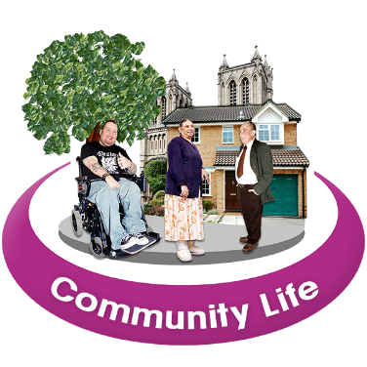
It is being part of a strong community.
It is having friends and relationships that are good for you.

It is having hobbies, work or learning you feel good about.

Other important things from the Act.

Advocacy services help people get information and services they need.

This helps people talk about their needs and wishes, understand their choices and make decisions.

Assessments are done to focus on what support people and their carers need.

By asking “What matters to you?” support works better for each person’s needs.

