

**IMPACT - The Evaluation of the Social Services and Well-being (Wales) Act 2014**

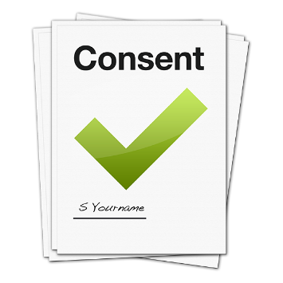

**Study consent – IMPACT Facebook Group**



Please write your full name here.

**_____________________________**



I was told about the IMPACT study and Facebook Group.



I was able to ask questions.



I know what is involved.



I understand I can leave the IMPACT Facebook Group at any time. I do not have to say why.



I am happy to take part in the IMPACT Facebook Group

Please sign your name here.

**___________________________________**

[](https://www.bing.com/images/search?view=detailV2&ccid=fsiaDqS1&id=519D118039D2C43FF431093D9ACAA27C117E57F4&thid=OIP.fsiaDqS16PqZoZwLnok8EQHaHa&mediaurl=https://101clipart.com/wp-content/uploads/04/Monthly%20Calendar%20Clipart%2011.jpg&exph=1584&expw=1584&q=calendar+clip+art&simid=608018001954803354&selectedIndex=172)

Please write today’s date here.

**______________________**

Please return the consent form to:

[sarah.wallace@southwales.ac.uk](mailto:sarah.wallace@southwales.ac.uk)

[lisa.griffiths@southwales.ac.uk](mailto:lisa.griffiths@southwales.ac.uk)