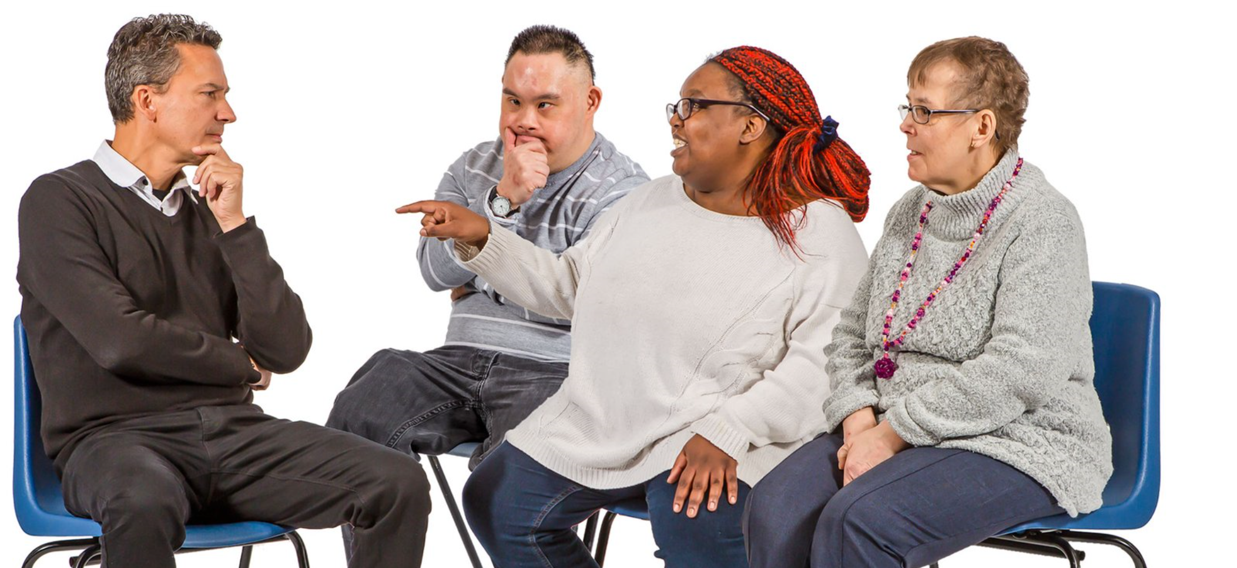
IMPACT - The Evaluation of the Social Services and Well-being (Wales) Act 2014

IMPACT Study information
We are looking at a government policy called the Social Services and Well-being (Wales) Act.

We want to hear from you about the support you get.

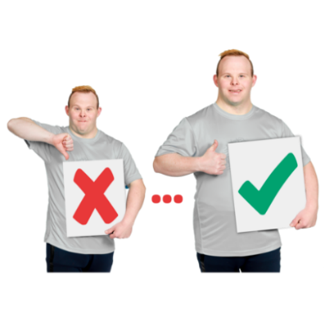
For example, if you are happy with the help you have or if you think it could be better.

Who will take part in the IMPACT study?
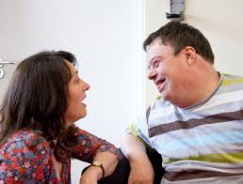
People living in Wales who get care and support will be asked if they want to take part.
There are lots of ways to take part.

You are being invited to take part because you are a member of the IMPACT Facebook Group.

You can choose to take part in some or all of the activities in the Facebook Group.
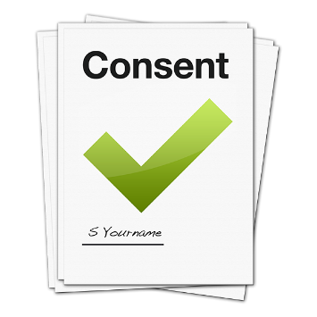
If you choose to take part, you will be asked to fill in and return the consent form.

Or you can complete the online consent form here:
https://southwales.onlinesurveys.ac.uk/consent-form-impact-facebook-group-easy-read

If you do not give consent, you can still take part but what you say will not be used in the study findings.

You can choose if you would like someone you know to help you with the activities or not.

You decide.

Will what I say be kept private?
What you say will be kept private.

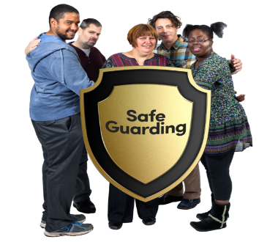
But if we think you, or someone else, is not safe we have to tell other people.

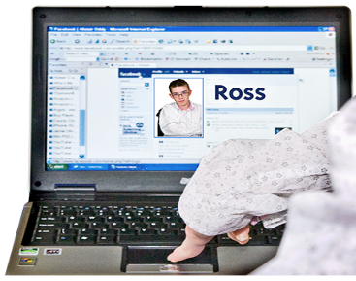
Anyone in the IMPACT Facebook Group will be able to see your name next to your posts and replies on the group.

You do not have to take part in the study.
You can change your mind. It is your choice.
You can leave the IMPACT Facebook Group at any time.
If you have any questions, you can ask:

Sarah Wallace or Lisa Griffiths, the Facebook Group moderators

Email: sarah.wallace@southwales.ac.uk
Email: lisa.griffiths@southwales.ac.uk

Or
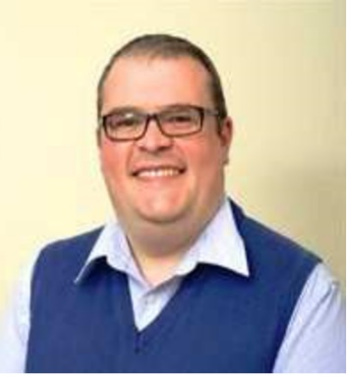
Professor Mark Llewellyn who is in charge of the study.

Email: mark.llewellyn@southwales.ac.uk

